Project 2 Report

Lead Time to Tender

# Amy Nestingen Winter 2020 <https://github.com/nestingen/DSC-680-Lead-Time-to-Tender>

# Introduction

In Supply Chain, freight accounts for a large portion of the overall cost. Whether that freight is expedited, shipped rail, or picked up by a customer affects the cost of the freight. Another factor of the freight cost is lead time to tender. Lead time to tender is the amount of time between the time the truck is requested to the requested date of the pickup. When this time is less than 24 hours, the cost of the freight goes up. Ideally there would be 72 hours between the request of the shipment date and requested pickup date but this is not always possible. With changing customer demand, sometimes it is not possible to give the carriers 72 hour notice. Over the past 4 months, freight costs have been on the rise. Graphic Packaging’s logistic teams have been looking for ways to decrease unnecessary costs. One place where this is possible is understanding the additional cost to request shipments with a lead time to tender less than 24 hours. That way plants and mills can make an informed decision when requesting to expedite shipments. The app will predict the cost of shipping a truck with a short lead time to tender. The data used in this project was based on Graphic Packing info but it has been changed so no proprietary information is shared.

# Data

I wanted this app to refresh automatically daily, so I only used QVD’s as source data. QVD’s are compressed files that are used in Qlik Sense. Graphic Packaging’s IT group has created many QVD’s that refresh daily that have source data from SAP, Mercury Gate, Panther, and more. The main building block for my data set is a QVD with source data from Mercury Gate. Mercury Gate is a third-party vendor that assists with managing our shipments. From this source I can derive the lead time to tender time from the shipment request date to the requested pickup date. I pulled data that had a shipment creation date in 2019 through 2020.

I also pulled in additional freight data from 4 other sources that refresh daily. These sources allowed me to add dimensions to my dataset like origin address, destination address, shipment status, carrier, and incoterms. This allowed me to filter to the relevant data in the analysis. I joined most datasets based on Delivery Number. This is a unique identifier for the shipment. I joined the carrier information based on the SCAC code. The SCAC is an industry used abbreviation for the carrier but I wanted to add in the full carrier name as well. The incoterms came from SAP which was joined based on the delivery number. I also added in a standard calendar so I could slice the data by day, week, quarter, or year. Finally, I joined a Location Master so I could assign business units to the origin ID’s and destination ID’s.

Once I had all of the base fields in my dataset that I needed, I added a few more columns based on the current dimensions or measures. I wanted to add these columns in the load script so it wouldn’t slow down the app for end users. The first calculated column I added was the time between requested shipment and requested pickup date aka Lead Time to Tender. I added a lead time to tender in days and hours depending on what end users wanted to see. I also assigned a Business Unit to each origin ID and destination ID based on the data in the location master. I created a low mile’s flag so I could quickly filter out loads that were less than 200 miles. This is important because we should not look at shuttles loads when investigating the cost of expedited shipments. Shuttle loads are usually under contract and it doesn’t matter when the load is requested in the system. Including these shipments could make loads with short lead time to tender less expensive than loads with a longer lead time. I also added a rate flag. There are some shipments in the dataset that have a zero cost. Some of these shipments are customer pickup which in this case the lead time to tender does not matter. In other cases, the missing cost is a data error which we would need to be filtered out of the overall analysis.

# Analysis

## Filters

For my analysis, I wanted to make sure I was working with an appropriate dataset. I wanted to keep the data in the model just in case we want to bring it in at a later data but added filters to the first dashboard so relevant dimensions can be easily filtered on. The filters I included are Mode, Miles Flag, Line Haul Cost Flag, Origin BU, and Origin Mill Type. In my dataset I had included expedited truck shipments, standard truck shipments, intermodal, and less than truck load. In our system, expedited shipments are not tagged to every shipment that that has a low lead time to tender. In my analysis, I only included standard trucks and expedited trucks. I did not want to include intermodal since this means the shipment went by truck and rail and the cost would not be standard. I did not want to use shipments that were shipped less than truck load since these products are shipped at a premium cost. The Miles Flag allowed me to filter in or out shipments that had a distance of over or under 200 miles. For my analysis, I chose to only include shipments that were greater than 200 miles to remove shuttle loads. The Line Haul Cost flag allowed me to only include shipments that had a cost greater than zero. Most of the shipments come out of mills and mill warehouses. The Logistics team was looking for high impact lanes where they could extend the lead time to tender. Because of this, I only wanted to focus on lanes coming out of the mills and mill warehouses. I selected only Mill and Warehouses for the Origin business unit and selected Mill and Mill Warehouses for the Origin Mill Type. With all of these filters applied, I was ready to start my analysis.

## Destination Business Unit Lead Time to Tender Groups

During my initial analysis, I wanted to understand how the lead time to tender changes depending on the Business Unit of the destination. In most cases, shipments are requested by the destination, so they oversee the lead time to tender. The bars below break out the deliveries and show the percent of trucks shipped with a lead time to tender under 24 hours, 48 hours, and 72 hours. The goal is to have shipments with a lead time of over 72 hours. Shipments between the Mill and non-Mill warehouses is represented in the first grouping of bars. This shows that about 18% of shipments are shipped with a lead time to tender of less than 24 hours. This is compared to shipments between the mill to customers and the mill to an AMC plant which are about 10% of the shipments. The AMC business unit includes plants in North America. This leads me to believe that the shipping lanes between the Mill to the plant warehouses could hold the greatest savings when the lead time is increased.

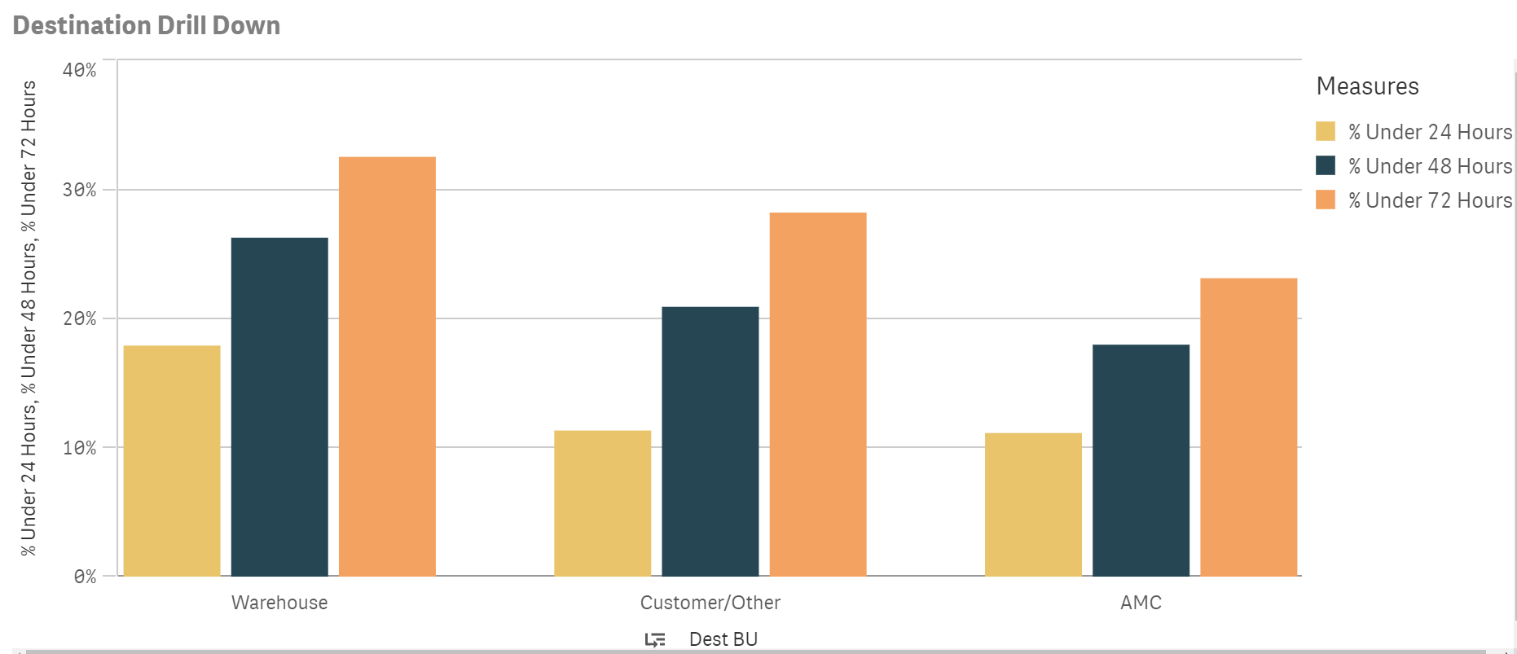

## Cost and Tons Shipped by Month and Lead Time

As I looked at the data, I did not want to lose sight of the overall picture. The bars below show the total shipping cost by month and the dots represent the tons shipped. The bars are segmented by shipments with a lead time to tender less than 24 hours, between 24 and 48 hours and between 48 and 72 hours. The tons are also separated this way. It is interesting to see how shipping cost has grown overall in the past 4 months but the tons shipped have not increased. This is because the trucking market has become more competitive which increased shipping cost regardless of lead time to tender. Months like July show when decreasing the shipments with a short lead time could result in large savings. The cost of shipments in the three groups are fairly even but the tons shipped in the 24-48 and 48-72 group and much more than the tons shipped in the less than 24 hour group. This means the cost of shipping trucks with a lead time to tender less than 24 hours is substantially more expensive.

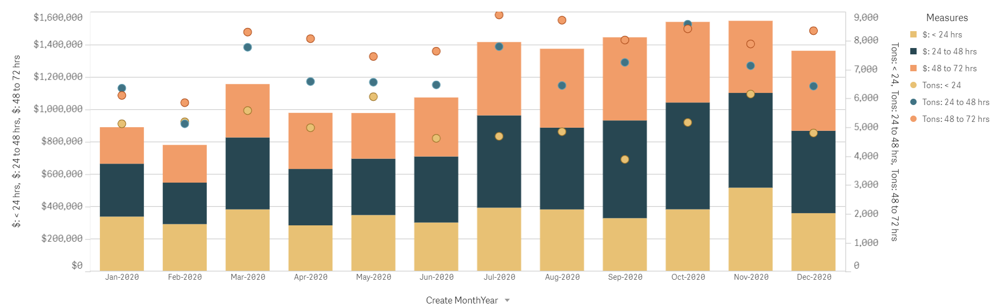

## Customer Service Impact

When a facility is forced to tender a load with a short lead time, they may not be able to use their main carriers. It was hypothesized that secondary carriers may not be as reliable. In the dataset, there are two types of customer service. One measures if the carrier delivered the shipment the day it was requested. The second measures if the carrier delivered the shipment within four hours of when it was requested. I looked at both instances of on time delivery and did not find a correlation between short lead time to tender and poor customer service.

# Model

## Annualized Savings Table

The table below shows the top 10 lanes that could have the most savings if all loads that are currently shipped with a lead time to tender of less than 24 hours are shipped with a lead time to tender of greater than 24 hours. This is the main table that I expect management will be interested in. Making changes to these few lanes could save an estimated $180k per year. The tons and line haul cost columns are based on the shipments in the last 12 trailing months. The $/Mile columns are based on rates for shipments from 8/1/2020 through 12/31/2020. This is because during this time frame rates have risen substantially. To understand the potential savings dollars, we must use rates from the current state of the trucking market.

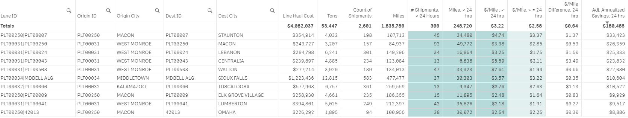

## Annualized Savings Map

The map below shows the savings a bit more visually. The color and thickness of line is weighted by the annualized savings. This map is only showing the top 10 lanes that are also shown in the table above. The Graphic Packaging mills shown on this map are in Louisiana and Georgia. You can see the shipments leaving these two facilities. The savings on a lane increases if the cost between a shipment with a short lead time is significantly more than a shipment with a long lead time and if there is a high number of tons shipped on that lane.

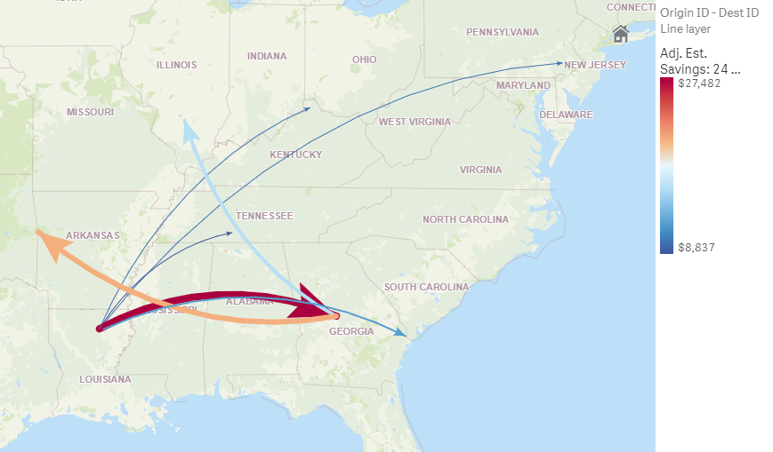

## Model for Users

The savings table and map are tools that can be used by end users to understand the cost of expediting their shipments. The savings table can be used to look up specific shipping lanes. When a plant, warehouse or mill is looking to request a shipment with a short lead time to tender, they can look up the lane and understand the cost of that choice. If all lanes could eliminate their shipments with a lead time to tender less than 24 hours, we could save an estimated 360k a year. There may still be times when a shipment needs to have an expedited lead time but this tool will give the facilities up to date data on what that decision will cost. The model is also predicting the cost of shipping a truck with a short lead time to tender. It is using data that is refreshed daily so that they understand the costs of the current truck market.

# Conclusion

As trucking costs continue to rise because of the competitive market, companies are looking to save money in this space. If Graphic Packing shifted all shipments that shipped with a lead time to tender less than 24 hours to greater than 24 hours, they could save 360k per year. Even if they transitioned their top 10 savings lanes, they could save $180K. The Qlik Sense app I created refreshes daily. It allows anyone in the company to evaluate how lead time to tender affects specific lanes and predict costs of truckloads. People can use this app as an up to date model to make real time decisions. Because there will always be a reason to expedite a shipment, realistically I think implementing this app into daily decisions could save the company $200k per year.

# References

THE COST IMPACT OF CYCLE TIME & LEAD TIME. (2020, August 04). Retrieved January 19, 2021, from https://spotinc.com/news/blog/cost-impact-cycle-time-lead-time/

Maps. (n.d.). Retrieved January 19, 2021, from https://help.qlik.com/en-US/sense/November2020/Subsystems/Hub/Content/Sense_Hub/Visualizations/Map/Map.htm

Tender Lead Time (TLT). (2019, November 06). Retrieved January 19, 2021, from https://knowledge.freightwaves.com/tender-lead-time-tlt/

# Appendix

Estimated Savings by Origin Business Units

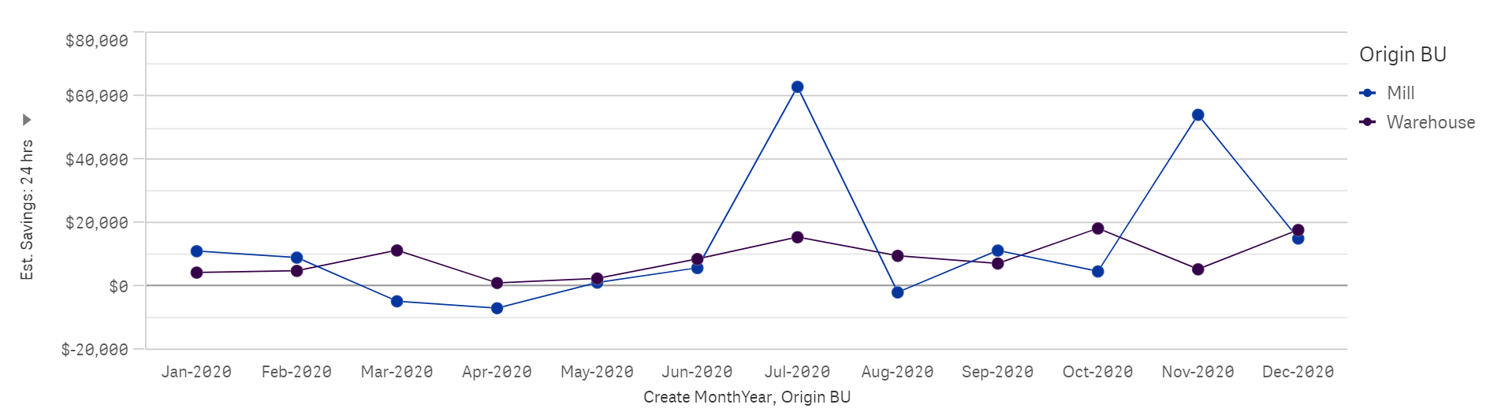

Estimated Savings by Destination Business Units

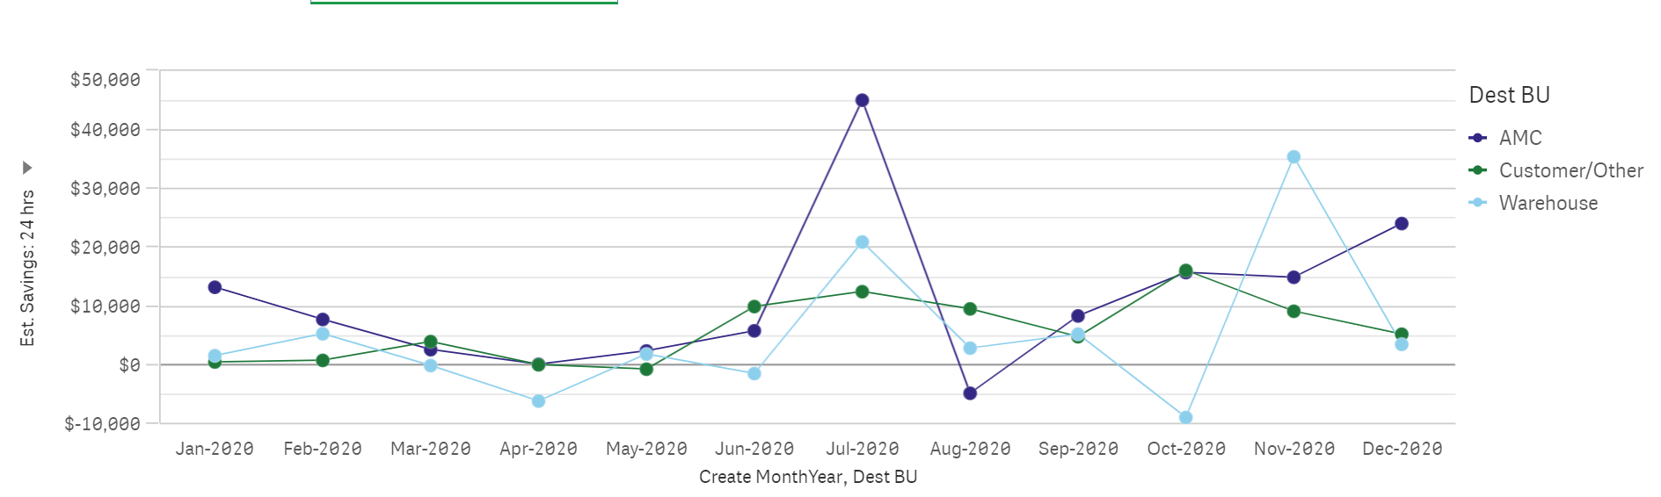

$/Mile for Shipments less than 24 hour lead time to tender vs. Greater then 24 hours by week

